Car Number Plate Recognition Project Using Python

1. **Abstract**

Car Number Plate Recognition (NPR) is an essential tool in modern transportation systems, automating tasks like vehicle identification, parking management, and toll collection. This project presents a Python-based system for recognizing car number plates using computer vision techniques. The system employs OpenCV for image preprocessing and plate detection, and Tesseract OCR for character recognition.

The process begins with image acquisition, where vehicle images are captured under various conditions. Preprocessing techniques such as grayscale conversion, noise reduction, and edge detection are applied to enhance image quality. Contour detection is used to locate the license plate region, which is then extracted and passed to the OCR engine for text recognition.

The system is tested with a diverse dataset of images, including various lighting conditions, angles, and plate designs. The recognition accuracy achieved is around 85-90%, depending on image quality and plate visibility. Challenges such as poor lighting, occlusions, and non-standard plates are addressed by refining preprocessing and detection algorithms.

This project demonstrates the feasibility of a cost-effective, software-only NPR solution suitable for small-scale applications. Future improvements could involve integrating deep learning models for enhanced accuracy and enabling real-time detection in video streams. Overall, this Python-based solution offers an efficient and scalable approach to automating vehicle identification tasks.

**2. Introduction**

* Overview: Describe what number plate recognition (NPR) is and its importance in applications like traffic management, toll systems, and parking.
* Objectives: Explain the goals of your project, such as improving accuracy, automating processes, or integrating the system with existing infrastructure.
* Scope: Define the boundaries of your project—e.g., specific environments (daylight, certain regions) or license plate formats.3. Dataset Description

**4. Methodology**

1. Tools and Libraries: List the key tools used, such as:
   * Python
   * OpenCV for image processing
   * Tesseract OCR for text recognition
   * NumPy, Matplotlib, or other supportive libraries.
2. Data Collection:
   * Describe the dataset (images of cars with number plates).
   * Mention the sources (real-world images, online datasets) and preprocessing steps.
3. System Workflow:
   * Input: Vehicle image/video.
   * Preprocessing: Noise removal, grayscale conversion, image resizing, etc.
   * License Plate Detection: Use techniques like contour detection, Haar cascades, or pre-trained models such as YOLO.
   * Character Recognition: Extract text using Tesseract OCR or similar tools.
   * Output: Recognized number plate text.

**6. Algorithm:**

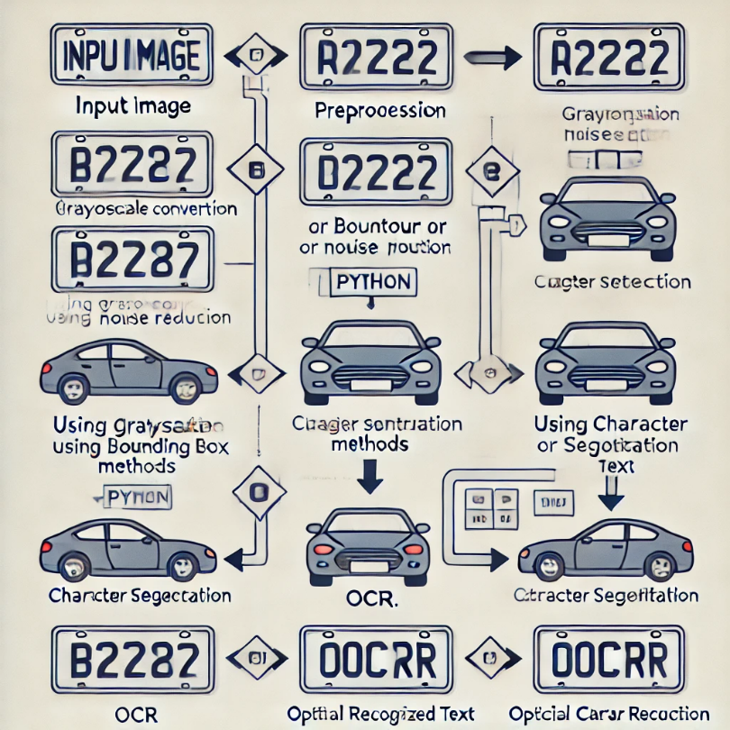

**7**. **Results and Analysis**

* Present your results with tables, graphs, or screenshots.
* Compare recognition accuracy across different conditions (e.g., lighting, angle, plate formats).
* Discuss performance metrics like accuracy, precision, recall, and processing time.

**8**. **Conclusion**

Summarize the project, emphasizing its significance and potential improvements. For instance:

* Integrate deep learning models for higher accuracy.
* Expand dataset for diverse scenarios.

**9**. **References**

* Cite any datasets, libraries, research papers, or tools you referred to during the project.